11AC 1300Mbps Nano-Sized Wireless USB Adapter
WL-700AC1300
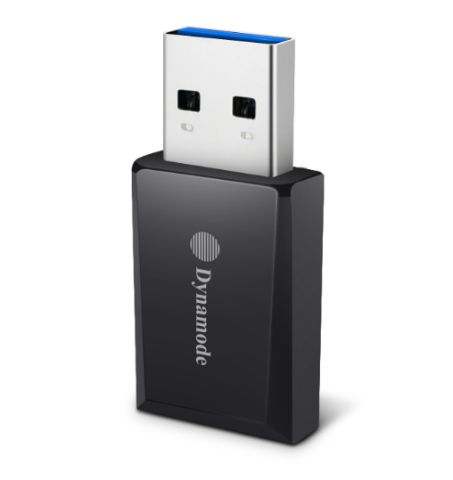

Descrption:
The Dynamode WL-700AC1300 is a USB 1300Mbps 5G/2.4G WiFi Adapter for Desktop and Notebook computers. The mini adapter is a 802.11AC Compatible High-Gain, High-Performance Dual-Band Wireless Adapter. It allows an instant WiFi upgrade to your laptop, PC, Mac, Notebook or Media device via the USB 3.00 port to allow a vastly superior WiFi signal via its high-gain internal antenna. It can operate up to speeds of 1300Mbps. It Supports MU-MIMO function, and fast downloading with Beam Forming function capability. It’s ideal for streaming media and gaming.
The WL-700AC1300 USB 3.0 is fully compatible with Windows, MAC OS X and Linux, and is compact enough so that it can be used as a direct replacement for your internal Wireless device and provides a safe WIFI experience.

Features:
- Supports MU-MIMO function
- Supports Beam Forming function
- Complies with IEEE 802.11ac/a/b/g/n standards
- Dual Band – works over 2.4GHz and 5GHz bands.
- Speeds up to 400Mbps on 2.4GHz and 867Mbps on 5GHz
- Works with all existing network infrastructures.
- Mini size,easy-to-install, plug and play
- Wireless security supports 64/128 WEP, WPA/WPA2, WPA psk/WPA2 psk (TKIP/AES),
- Supports IEEE 802. 1x
- Supports Windows, Mac OS, Linux Kernel
- Plug n’ Play USB3.0 interface

SPECIFICATIONS:
- Standards ：IEEE 802.11ac,IEEE 802.11a, IEEE 802.11n, IEEE 802.11g, IEEE 802.11b
- Wireless Signal Rates With Automatic Fallback ：11ac: Up to 867Mbps(Dynamic) 11n: Up to 400Mbps (Dynamic) 11g: Up to 54Mbps (Dynamic) 11b: Up to 11Mbps (Dynamic)
- Chipset：RTL8812BU
- Frequency Range: 2.4-2.4835GHz/5.15-8.825GHz
- Wireless Transmit Power: 20dBm (EIRP)
- Modulation Type: DBPSK,DQPSK,CCK, OFDM, 256QAM
- Receiver Sensitivity: 867M:-53dBm@10%PER 300M: -68dBm@10% PER 54M: -72dBm@10% PER 11M: -85dBm@8% PER
- Work Mode: Ad-Hoc Infrastructure
- Wireless Security: WPS,64/128bit WEP,WPA/WPA2,WPA-PSK/WPA2-PSK(TKIP/AES)
- System: Windows VISTA/Win7/Win8/Win8.1/Win10/Linux/Macintosh
- Interface: USB3.0 connector
- Antenna Type: Internal PIFA Antenna
- Antenna Gain: 2dBi
- Dimensions: 37.7*17.7*7.8mm
- Operating Temperature: 0°C~40°C
- Storage Temperature: -20°C~60°C
- Relative Humidity: 10% ~ 90%, non condensation
- Storage Humidity: 5%~95% non-condensing

